` | Qiqqa User Manual  Version 1.0.0-1

Contents
Contents 3
About this Manual 5
How to use this manual 5
Disclaimer 5
Version Number 5
What's new 5
Copyrights 6
Acknowledgments 6
Feedback 6
Basic Concepts 7
Fundamental Terms 7
Reference Management terms 7
How Reference Manager works 11
What Reference Managers can do for you 11
Typical workflow 12
The Qiqqa Interface 13
Qiqqa screens 13
The Toolbar system 13
The Operational modes of Qiqqa (screens) 18
The Launch Screen 18
The Home screen 19
The Guest Screen 20
The Incite Screen 20
The Expedition Screen 21
The Brainstorm Screen 21
The Web Screen 22
The Tools Screen 22
The Help Screen 22
The search system 23
Overview 23
Terms 24
Fields 24
Term Modifiers 24
Wildcard Searches 24
Fuzzy Searches 25
Proximity Searches 25
Range Searches 25
Boosting a Term 25
Boolean Operators 26
Grouping 26
Field Grouping 27
Escaping Special Characters 27
Search history 27
G. FAQ 29
H. Glossary 31
I. What's new? 33

About this Manual
This is the user's manual for the Qiqqa, an open source Reference Manager.

How to use this manual
This manual is meant for different types of users of qiqqa. You may be a researcher in need of managing your citations, or a casual user who wants help in discovering knowledge in a particular field by systematically reading through books/magazines or online material.
The best way to read this manual is to read it from start to finish: @@@add other possible sequences
In fact, be sure to read the next (“Introduction”) chapter.
The manual provides links to additional reference material available on Internet. Hyperlinks in this manual are denoted with brown text (NOT as underlined blue text).

Disclaimer
The manual is presented as a free guide, on “as is” basis. The manual is supposed to be a guide for the user; not an authentic reference book.
Due care is taken to ensure that the manual is accurate and matches the current version of Qiqqa.
However, it possible that you are using an outdated version of this manual or Qiqqa, in which case there would be some mismatches. If so, please send me an email and I will correct the anomaly in the next version of the manual.
The author is not responsible for any loss or damages arising out of use, misuse or abuse of the information presented here; or errors in the manual.
Please use it at your own risk.

Version Number
This manual will be updated from time to time, to keep up with the changes in Qiqqa; or to add more help material.
The version number of the manual is simply the Qiqqa's version number followed by a serially incremented number. For example, the number V82.0.7568.29227.2 means the second manual released for Qiqqa version V82.0.7568.29227.
The manual will carry its version number on the front cover, so that you can easily find out whether you have the latest manual.

What's new
The latest changes in the manual is provided in the Appendix I. If you have read the previous version thoroughly, you can simply go through these changes to understand what has changed in both <product> and manual.

Copyrights
This manual is licensed under a Creative Commons Attribution-NoDerivs 3.0 Unported License.
Due care is taken to use non-copyrighted material in this manual. If you notice any copyright infringement, please bring it to my notice, and I will correct it immediately. Thanks in advance!

Acknowledgments
@@@

Feedback
This section refers to feedback about this manual only. To provide a feedback about <product> (bugs, feature request or support requests), please visit @@@link
You are most welcome to give any suggestions to make this manual more accurate and comprehensive. In future versions, I will be adding more music-related text, so any suggestion or contribution in this aspect are also welcome.
Please send a mail to raindrops.fromsky@gmail.com, Please begin the subject line with the words “<product> User Manual”, so that your mail does not get rejected by my spam filter.
If you feel that the manual does not cover a topic in sufficient detail, please let me know.
If you can, please share any details that are missing here, or point to sources of such information. Thanks in advance!

Basic Concepts
This manual uses some terms and concepts that may not be known to you. Understand them first.

Fundamental Terms
The terms used in the discussions throughout the manual are explained here.
The list is not presented in alphabetical order: The foundation concepts are explained first, and then higher-level concepts based on them are explained later.
More general terms are covered in the Glossary.
Term | Meaning
LMB | Left Mouse Button
RMB | Right Mouse Button
Click | Press the LMB momentarily and release it immediately.
Right-click | Press the RMB momentarily and release it immediately.
Hover | Move the mouse till the pointer is on the target object, but do not click LMB or RMB.
Context menu | When you hover the mouse pointer on various parts of <product> interface and press RMB, you get a pop-up menu. The options available in this menu change based on the current context (combination of all applicable factors). Hence this menu is called a context menu.
Mousewheel | The scrolling wheel of the mouse, located between LMB and RMB.
Roll the mousewheel | Turn the mousewheel up/down
Middle-click | Click on the mousewheel as if it is a button (just like LMB/RMB).
Drag with mouse | Click LMB on a control, and without releasing the LMB, move the mouse.  (Release the LMB when done).
Right-drag with mouse | Click RMB on a control, and without releasing the RMB, move the mouse.  (Release the RMB when done).
Middle-drag with mouse | Click MMB on a control, and without releasing the MMB, move the mouse.  (Release the MMB when done).
Draw with mouse | Click with LMB, hold down and draw a shape with the mouse pointer.  When done, release LMB.

Reference Management terms
In this section, we will see terms that are specific to Reference Managers.

Term | Meaning
Reference | When we write a research paper, we often rely on prior knowledge. However, we cannot just quote any general opinion or “traditional wisdom”: We need to prove that the statement is a result of systematic research that is already peer-reviewed and accepted in the scientific community.  In fact, when you start looking for such authentic references, you may realize that your understanding was incorrect, or that the statement is true only under specific circumstances.  So when you produce your own paper, it is a practice to support your assertions by referring to the original research that discovered (or proved) that fact.  Such references allow the reader to look up the original reference and check the veracity of your statement. Sometimes the source statement may be misquoted, faulty, subjective, conditional, misconstrued or untrue. In such cases, your own discovery becomes questionable.  Thus references are supposed to provide a solid foundation for your research. It also gives credit to the original authors for their creative and intellectual works that you used to support your research.
Citation | When a reference is mentioned in your article, it becomes a citation.  Typically, this is in the form of inserting a footnote, or endnote in the text. The structure of the note varies greatly depending on what protocol you have to follow. This is called “Citation style”.  Typically, a citation can include the author's name, date, location of the publishing company, journal title, or DOI (Digital Object Identifer). But they all differ in the sequence, and the format in which each element is written.  Different institutions (universities, professional associations, scientific/professional journals, etc) have standardized their own unique citation style, and if you submit an article to them, you must follow that particular style.  Luckily, most reference managers can switch between the standard citation styles.
Online catalog | An online library catalog is an electronic bibliographic database that describes the books, videotapes, periodicals, etc. carried by a particular library. In the old days, each library had a catalog made out of printed cards. The online library catalog is the modern equivalent. In most cases, they also provide a link to download a pdf file of the paper.  Some libraries are dedicated to a particular field of knowledge, such as medical, environmental, engineering, etc. Some catalogs (e.g. Google Scholar) are generic.
Intranet library | @@@ explain
Bundle library | @@@ explain
Syncing a library | @@@ explain
Textify | If the pdf file has searchable text, Qiqqa goes through the entire text and remembers each word by its page number and location (coordinates on the page). This process is called “textification”, and is like indexing of the document.
OCR | Optical Character Recognition.  Often pdf files are created by just taking an image (photo/scan) of each page. While you can read such files, your pdf reader software cannot find any text in it. Therefore you cannot conduct searches in such files.  This is a huge limitation.  Fortunately, the file can be OCRed to recognize the text content on each page.  - Qiqqa uses Tesseract OCR engine for the OCR. It extracts each word separately and then assigns it coordinates on the page to mimic the original page. This ensures that OCRed page shows all text in its original location.  - If there are any images, charts, or figures in the file, the OCR engine will keep them in their original form. It will simply copy such area, while preserving the shape, size, position and color.  - If the text is in a tabular form, it is recognized and placed in an identical table.  When a pdf is OCRed, textification of the document follows as the second step.  Thus the OCRed file looks just like the original file, but now it contains fully searchable text. Now you can copy such text from the pdf file, and paste it anywhere.
Note:
Both OCR and textification processes take up a very long time. Qiqqa is designed to carry out both processes as low-priority background processes, so as not to overload your laptop. Whenever the laptop becomes idle, Qiqqa automatically springs to action and starts the OCR and textification tasks. Qiqqa’s status bar shows the completion status for OCR+Textification.
Note that after the file is OCRed and/or textified, Qiqqa still has to analyze its contents and integrate its knowledge with the rest of the knowledge base. Therefore, you must give Qiqqa enough time to let it finish all OCR and Textification jobs.
Remember to keep Qiqqa running even when you are not using it actively.
Autotag | Qiqqa automatically applies tags to each file by analyzing its contents.  @@@ explain the logic behind autotags. Does it rely on a single file or on the collection of the files?
Theme | @@@ explain the concept of themes, and how the algorithm derives them.

How Reference Manager works
In this chapter, we will see how the Reference Manager works.
These products have a great variation in their features. Based on the actual features, a particular product can be classified as Reference management software, citation management software, bibliographic management software, or research management software. But here we will refer to all of them as “reference managers” (“RM” in short).
In the simplest form, you read books and online articles, and gather information. If your project is large, you may have to take extensive notes, and also keep a track of your source of information (so that you can cite them accurately). Then you organize this information, and discover some new fact or pattern. You write an article (“paper”) describing what you discovered. Whenever needed, you mention your sources of information by inserting citations.

What Reference Managers can do for you
In this, the minimum role played by a citation manager is twofold:
- It stores your citations (that is, it remembers which article has which important paragraph/image/table), and your own summary of it.
- When you are composing the article in a word processor or LaTeX editor, it lets you insert those citations anywhere you want, in the desired style.
All RMs can do this. Some RMs provide go beyond the purely citation management functions, and help you with the other aspects of your research (such as knowledge search, knowledge discovery, knowledge sharing). Such features can save a lot of time and effort, and so they must be considered in selecting and using the RM.
Here is a list of such additional functions (Qiqqa provides all of these functions).
- Integration with a browser:
When you are browsing any website, a notification lets you know if there is any text that you can bookmark in your RM. You can simply highlight the text, and the RM will store the text, and also remember the URL of the page.
- Ripping the list of downloadable files on a page
When you are searching at online catalog sites such as Google Scholar, the RM can create a list of all pdf files that are listed on the current page, and present that list to you. You have the option to select any (or all) files, and then download all the files with a single click.
- Recommend useful papers
When you search for online papers, the RM can suggest papers that may be of more use to you.
They do this by analyzing your existing collection, and finding search phrases.
  - Some RMs have a manually curated list of recommended papers (paid service)
  - Some RMs have a system of user-rated papers (peer rating).
Either way, you can ignore the suggestions and continue searching the internet based on your key phrases.
- Store pdf files
Store the pdf files in local folders and manage the directory.
- OCR
OCR a scanned/image-based pdf file, so that you can search and copy its text.
- Annotate pdf files
Annotate the pdf files, and extract all annotations (even done with external pdf readers) as a summary. This summary can be directly pasted in your own article.
- Work concurrently in a team
Collaborative features: All documents are shared on a server. Multiple members of a team can log in the server and work on the document and also on the output document.
- Work inside a word processor
Addons for word processors (MicroSoft Word, LibreOffice Writer, etc). This adds a citation toolbar in the word processor. So, when you are preparing your article in the word processor, you can directly insert the citations; rather than having to copy each citation from the RM, and then switch to word processor to paste it in the document.
- Tags
Attach tags to the information you have collected (snippet from a web page, or a pdf file). Tags are useful for searching the documents later.
  - Some RMs allow you to use social tags. These tags are created and shared by the global community of all users, and many online documents are already tagged with them. This saves a lot of time for you.
  - Some RMs allow you to attach attributes to the information. While a tag has a single value, an attribute has multiple values, such as yes/no, or a number (1-5). Thus an attribute can serve you better.
- Mind map/Concept map
Create a mind map or a concept map.
These maps are very useful:
  - They can be used as advance organizer, which directs your attention to what is important in the coming material, highlights the relationships between different entities, and provides a linkage with relevant prior knowledge.
  - They can be used for sensemaking (to crystallize your understanding of the subject).
  - They also clearly show you the gap areas where you need to collect more information.

Typical workflow
There is no unique way to conduct research, but in general, the research workflow is as follows:
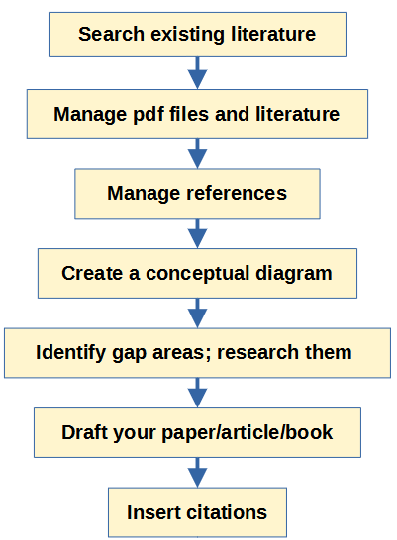
Some users may not want to publish papers, so the citation part is not applicable to them. They would use the knowledge discovery and knowledge management parts of the workflow.

The Qiqqa Interface
In this chapter, the interface of Qiqqa is described.
Qiqqa does not have the traditional Menu system. Instead, all its functions are accessible through its toolbar system. Qiqqa has a tabbed interface, like a browser. In each tab, it has a screen that is designed to serve a single function.

The Toolbar system
At the top of each screen, Qiqqa has a toolbar, which has large icons, with labels below each icon. For example, here is the toolbar for the Home page.

When you click on an icon, Qiqqa launches the corresponding screen in a new tab. The original screen remains open in the current tab.
For example, in the ribbon for the Home screen, if you click on the Libraries icon, Qiqqa launches the Guest tab in a new tab:
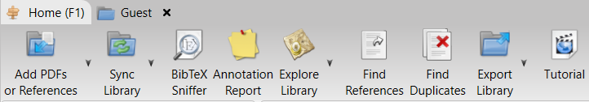
- In Qiqqqa, the current tab looks darker than the other tab. (In the screenshot above, the current tab is “Guest”.
In the menus, the symbol “>” is used to denote sequential selection of menu items.
For example, Home > Libraries means first select Home option in the menu, and then select Libraries option. (When you select one menu option, the menu changes. Thus the next option is available from the changed menu.)

Menu: Home
Option | Action taken
Libraries | Launch the Libraries screen in a new tab.
InCite | Launch the InCite screen in a new tab.
Expedition | Launch the Expedition screen in a new tab.
Brainstorm | Launch the Brainstorm screen in a new tab.
Web Tools | Launch the Web Tools screen in a new tab.
Help | Launch the Help screen in a new tab.

Menu: Home > Libraries
Option | Action taken
Open a Library
Sync Libraries
Create/Join Intranet Library
Download a Bundle Library

Menu: Home > Tools
Option | Action taken
Convert DOC and DOCX files to PDF
Pause/resume OCR
Help us translate Qiqqa!
Backup/Restore
Qiqqa Configuration

Menu: Home > Help
Option | Action taken
The Qiqqa Manual
The Welcome Wizard
Online Help
About Qiqqa
Bundle logs for Qiqqa support

Menu: Home > Libraries > Open a library (Guest)
Option | Action taken
Add PDFs or References
Sync Library
BibTeX Sniffer
Annotation Report
Explore Library
Find References
Find Duplicates
Export Library
Tutorial

Menu: Home > Libraries > Open a library (Guest) > Add PDFs or References
Option | Action taken
Add non-PDF Reference
Add PDF Documents
Add Folder
Watch Folder
Import from another Reference Manager
Copy Another Library
Recover unregistered PDFs in this library

Menu: Home > Libraries > Open a library (Guest) > Sync Library
Option | Action taken
Full Sync
Partial Sync
Sync Details
View Online
Top Up
Edit/Delete
Invite & Share
Change Public Status

Menu: Home > Libraries > Open a library (Guest) > Explore library
Option | Action taken
Explore this library using Qiqqa Expedition.
Explore this library in a Brainstorm.
Explore this library in a Pivot.

Menu: Home > Libraries > Open a library (Guest) > Export library
Option | Action taken
Export Library
Export BibTeX records for use with LaTeX.
Export Refs to Word XML (not recommended)
Export Citation Matrix
Export Linked Docs
Export Code Annotations
Build Bundle Library

Menu: Home > Incite
Option | Action taken
Copy Snippet
Add Citation (Author, Year)
Add Citation Author (Year)
Add Bibliography Section
Reformat Document
style CSL
Citation Style
Tools
Tutorial

Menu: Home > Incite > Citation style
Option | Action taken
Pick CSL style
Browse CSL Library
Open Web CSL Editor (Beginner)
Open Qiqqa CSL Editor (Advanced)

Menu: Home > Incite > Tools
Option | Action taken
Use Abbreviations
Add Custom Abbreviations
Open InCite Popup
Show Used Citations
Pause InCite
Launch Word

Menu: Home > Expedition
Option | Action taken
Library for expedition
Refresh expedition
Number of themes
Use autotags?
Use Tags?
Refresh autotags?
Manage autotags
Export themes
Tutorials

Menu: Home > Brainstorm
Option | Action taken
New Brainstorm
Open Brainstorm
Save Brainstorm
Save As Brainstorm
Move & Pan
Add Node
Add Connector
Auto Arrange
Connect to existing nodes
Always create new nodes
Zoom out
Zoom in
Print

Menu: Home > Web browser
Option | Action taken
New
Back
Forward
Web address
Search the web
EZProxy
Print
Convert to pdf
Grab all pdfs
Add pdf to library

The Operational modes of Qiqqa (screens)
Qiqqa has the following screens (modes of operations):
- The launch screen
- Home (shows statistics)
- Incite (adding citation)
- Expedition (finding documents with similar themes and explore them)
- Brainstorm (creating a mind map or concept map)
- Web (searching the online research catalogs using the embedded browser)
- Tools
- Help
These screens are described below:

The Launch Screen
This “flash screen” is seen only when you launch the application.
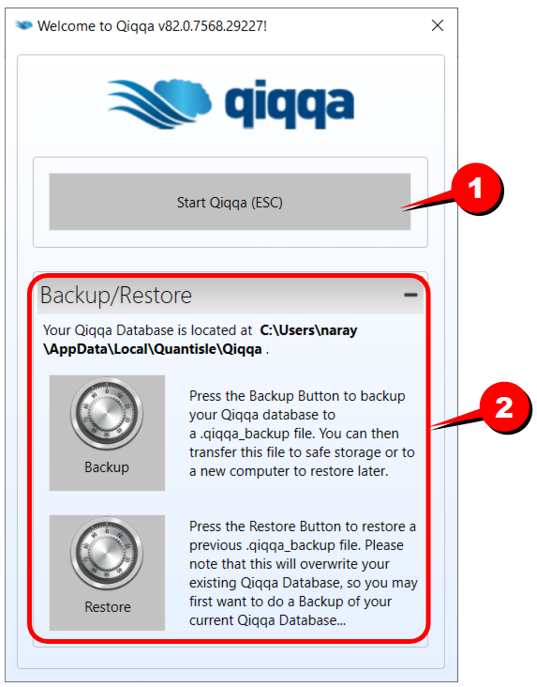
SL | Remarks
1 | Click here (or press ESC to start Qiqqa.
2 | The storage/backup options are given at the start. This allows you to load a particular database at the start of the session.  .

The Home screen
(shows statistics)
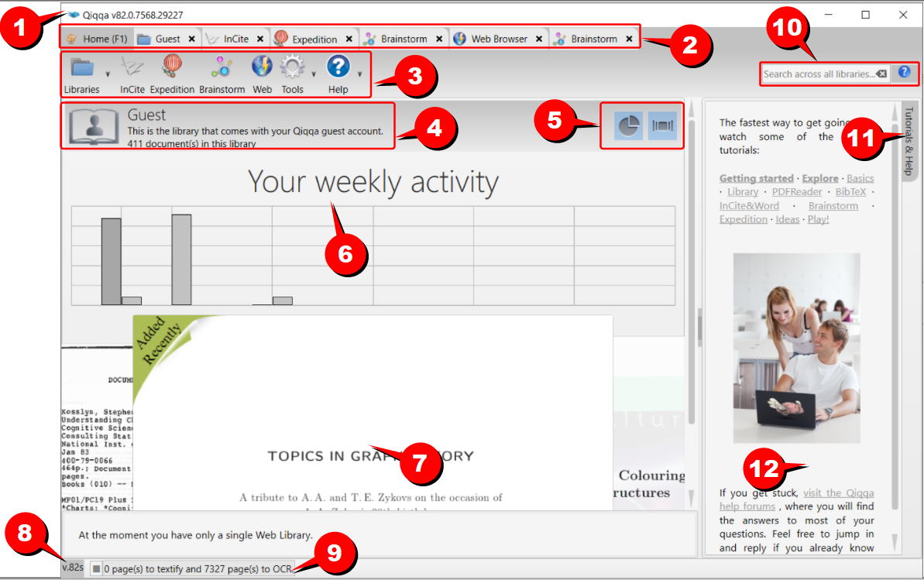

SL | Remarks
1
2
3
4
5
6
7
8
9

The Guest Library Screen
This screen shows the default (unnamed) library of Qiqqa.
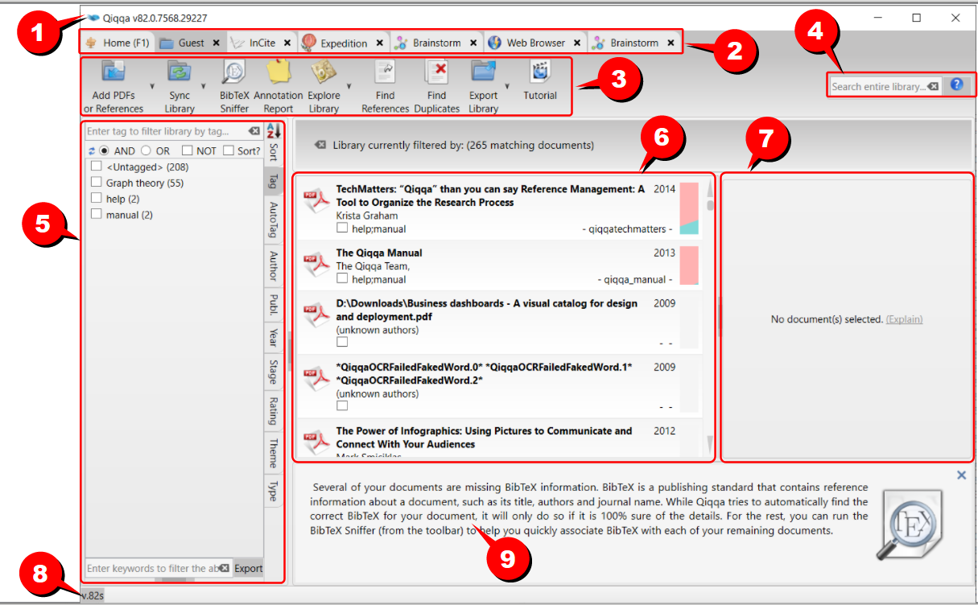

SL | Remarks
1
2
3
4
5
6
7
8
9

The Incite Screen
(adding citation)
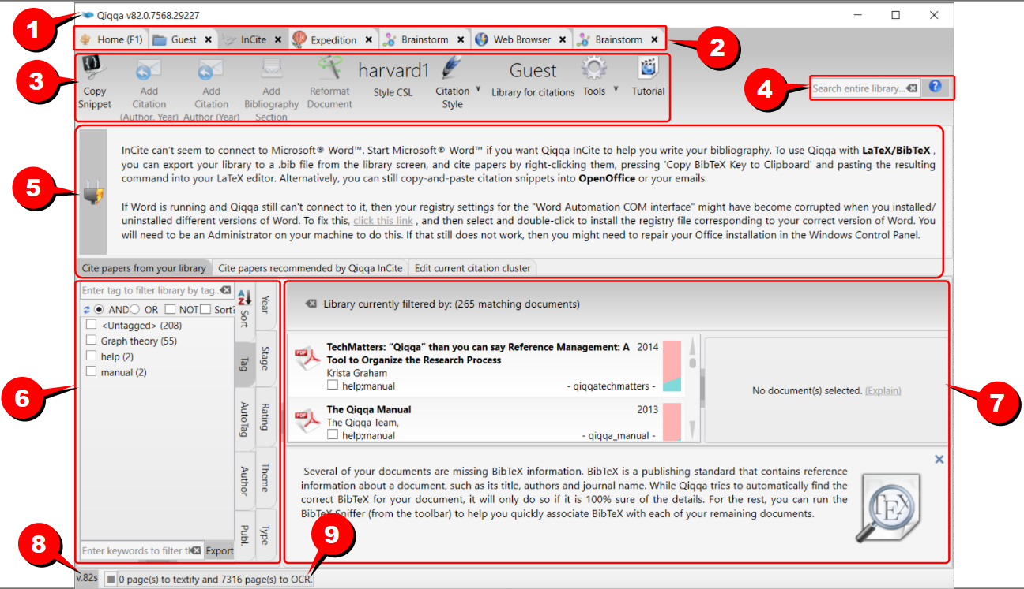

SL | Remarks
1
2
3
4
5
6
7
8
9
10

The Expedition Screen
(finding documents with similar themes and explore them)
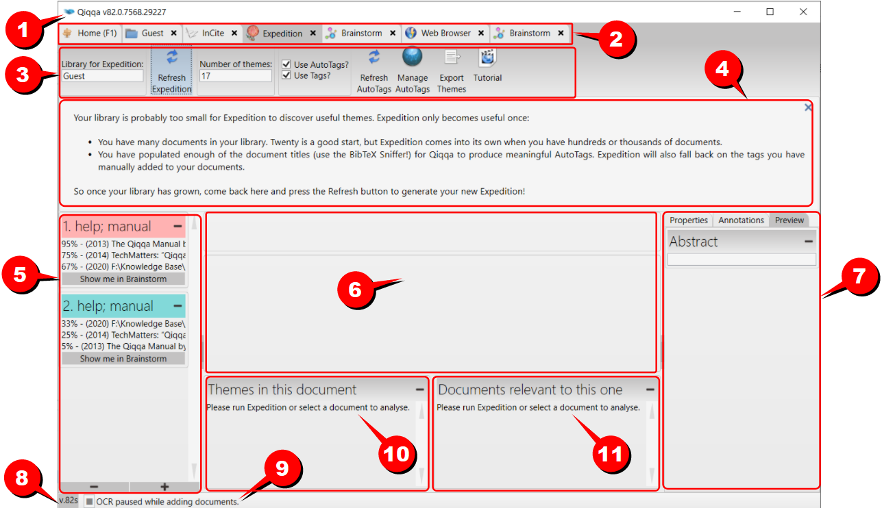

SL | Remarks
1
2
3
4
5
6
7
8
9
10
11

The Brainstorm Screen
(creating a mind map or concept map)
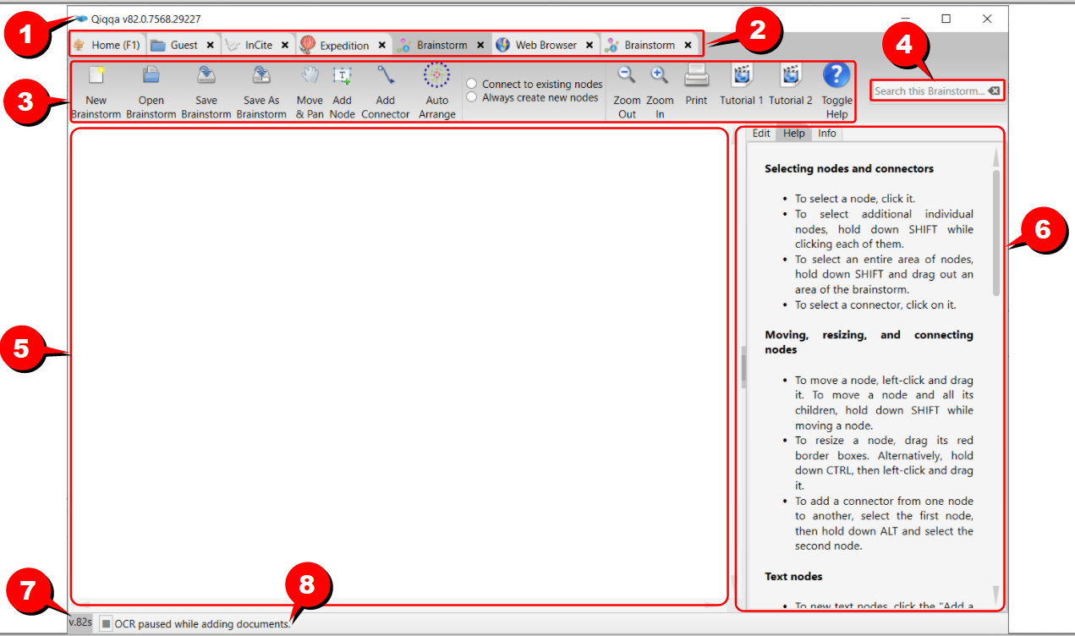

SL | Remarks
1
2
3
4
5
6
7
8

The Web Screen
(searching the online research catalogs using the embedded browser)
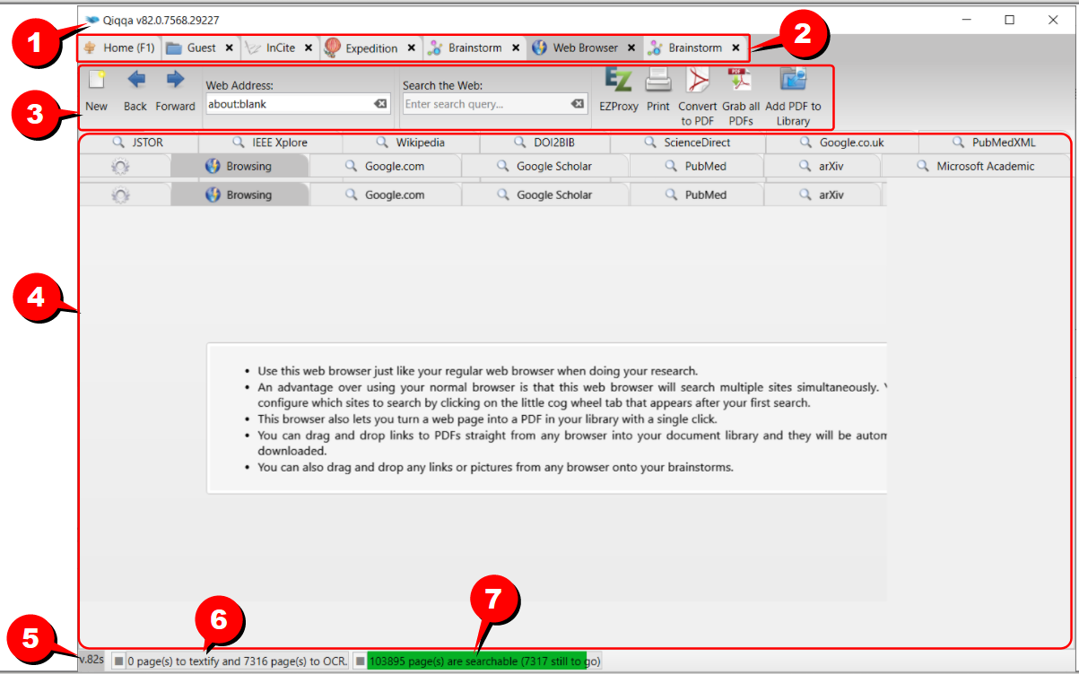

SL | Remarks
1
2
3
4
5
6
7

The Tools Screen

The Help Screen

The search system
Qiqqa has powerful searching features.
In general you can type a free-form search query into any of the Qiqqa search fields. Qiqqa will do its best to work out what you are looking for. If you suspect that your search results are incomplete, you can rebuild your search index at any point. Go to the library screen, select all documents (CTRL-A), right-click, and select "Reindex this document."
You probably want to know these basics:
- Terms - you can search for single terms (just a word on its own like test) and for phrases (surrounded in quotes like "libor market models").
- Fields - you can limit your search to specific fields by prepending a search term with the field name and a colon (like title:libor or author:"samuel jackson"). The generic fields that Qiqqa supports are: fingerprint, page, title, author, year, comment, tag, annotation, bibtex.
- Premium Fields - You can restrict your searches to ANY of the fields that you have added in your PDF BibTeX records. For example, if you have marked some PDFs with a BibTeX field named "jurisdiction", then a search query of "reinsurance +jurisdiction:MA" will return only those PDFs containing the word "reinsurance" that also have a BibTeX record with a "jurisdiction" field set to "MA".
- Booleans - try things like (copper OR aluminium) AND mining or "fried green" NOT tomatoes. NB: the booleans AND OR NOT must be in capital letters.
Qiqqa also supports the following advanced search options:
- Shorthand booleans - try things like copper +mining or +"fried green" -tomatoes.
- Wildcards - ? is the single character wildcard (e.g. te?t matches test, tent and text). * is the mulitple character wildcard (e.g. t*t matches test, tacit, teapot and toot).
- Fuzzies - by tailing a term with a ~ you kick in the fuzzy search (so africa~ will match africa, arfica, afrika and other misspellings and similar words). You can control the fuzziness by tailing a number from 0 (very fuzzy) to 1 (not fuzzy) (e.g. africa~0.8).
- Proximities - similar to fuzzies, you can specify that two words must appear close together (e.g. "interest model"~5 will find "interest rate model" and "some interest in that model" - the words are less that 5 words apart).
- Ranges - try something like year:[2002 TO 2004]. Inclusive range queries are denoted by square brackets. Exclusive range queries are denoted by curly brackets.
- Boosting - you can weight some terms more than others using the ^ (e.g. copper^4 iron will return documents with copper higher in the ranking than those with iron because copper scores roughly 4 times more than iron.

Overview
Although Qiqqa provides the ability to create your own queries through its API, it also provides a rich query language through the Query Parser, a lexer which interprets a string into a Qiqqa Query using JavaCC.
Generally, the query parser syntax may change from release to release. This page describes the syntax as of the current release. If you are using a different version of Qiqqa, please consult the copy of docs/queryparsersyntax.html that was distributed with the version you are using.
Before choosing to use the provided Query Parser, please consider the following:
- If you are programmatically generating a query string and then parsing it with the query parser then you should seriously consider building your queries directly with the query API. In other words, the query parser is designed for human-entered text, not for program-generated text.
- Untokenized fields are best added directly to queries, and not through the query parser. If a field's values are generated programmatically by the application, then so should query clauses for this field. An analyzer, which the query parser uses, is designed to convert human-entered text to terms. Program-generated values, like
- dates, keywords, etc., should be consistently program-generated.
- In a query form, fields which are general text should use the query parser. All others, such as date ranges, keywords, etc. are better added directly through the query API. A field with a limit set of values, that can be specified with a pull-down menu should not be added to a query string which is subsequently parsed, but rather added as a TermQuery clause.

Terms
A query is broken up into terms and operators. There are two types of terms: Single Terms and Phrases.
A Single Term is a single word such as "test" or "hello".
A Phrase is a group of words surrounded by double quotes such as "hello dolly".
Multiple terms can be combined together with Boolean operators to form a more complex query (see below).
Note: The analyzer used to create the index will be used on the terms and phrases in the query string. So it is important to choose an analyzer that will not interfere with the terms used in the query string.

Fields
Qiqqa supports fielded data. When performing a search you can either specify a field, or use the default field. The field names and default field is implementation specific.
You can search any field by typing the field name followed by a colon ":" and then the term you are looking for.
As an example, let's assume a Qiqqa index contains two fields, title and text and text is the default field. If you want to find the document entitled "The Right Way" which contains the text "don't go this way", you can enter:
title:"The Right Way" AND text:go
or
title:"Do it right" AND right
Since text is the default field, the field indicator is not required.
Note: The field is only valid for the term that it directly precedes, so the query
title:Do it right
Will only find "Do" in the title field. It will find "it" and "right" in the default field (in this case the text field).

Term Modifiers
Qiqqa supports modifying query terms to provide a wide range of searching options.

Wildcard Searches
Qiqqa supports single and multiple character wildcard searches within single terms (not within phrase queries).
To perform a single character wildcard search use the "?" symbol.
To perform a multiple character wildcard search use the "*" symbol.
The single character wildcard search looks for terms that match that with the single character replaced. For example, to search for "text" or "test" you can use the search:
te?t
Multiple character wildcard searches looks for 0 or more characters. For example, to search for test, tests or tester, you can use the search:
test*
You can also use the wildcard searches in the middle of a term.
te*t
Note: You cannot use a * or ? symbol as the first character of a search.

Fuzzy Searches
Qiqqa supports fuzzy searches based on the Levenshtein Distance, or Edit Distance algorithm. To do a fuzzy search use the tilde, "~", symbol at the end of a Single word Term. For example to search for a term similar in spelling to "roam" use the fuzzy search:
roam~
This search will find terms like foam and roams.
Starting with Qiqqa 1.9 an additional (optional) parameter can specify the required similarity. The value is between 0 and 1, with a value closer to 1 only terms with a higher similarity will be matched. For example:
roam~0.8
The default that is used if the parameter is not given is 0.5.

Proximity Searches
Qiqqa supports finding words are a within a specific distance away. To do a proximity search use the tilde, "~", symbol at the end of a Phrase. For example to search for a "apache" and "jakarta" within 10 words of each other in a document use the search:
"jakarta apache"~10

Range Searches
Range Queries allow one to match documents whose field(s) values are between the lower and upper bound specified by the Range Query. Range Queries can be inclusive or exclusive of the upper and lower bounds. Sorting is done lexicographically.
mod_date:[20020101 TO 20030101]
This will find documents whose mod_date fields have values between 20020101 and 20030101, inclusive. Note that Range Queries are not reserved for date fields. You could also use range queries with non-date fields:
title:{Aida TO Carmen}
This will find all documents whose titles are between Aida and Carmen, but not including Aida and Carmen.
Inclusive range queries are denoted by square brackets. Exclusive range queries are denoted by curly brackets.

Boosting a Term
Qiqqa provides the relevance level of matching documents based on the terms found. To boost a term use the caret, "^", symbol with a boost factor (a number) at the end of the term you are searching. The higher the boost factor, the more relevant the term will be.
Boosting allows you to control the relevance of a document by boosting its term. For example, if you are searching for
jakarta apache
and you want the term "jakarta" to be more relevant boost it using the ^ symbol along with the boost factor next to the term. You would type:
jakarta^4 apache
This will make documents with the term jakarta appear more relevant. You can also boost Phrase Terms as in the example:
"jakarta apache"^4 "Apache Qiqqa"
By default, the boost factor is 1. Although the boost factor must be positive, it can be less than 1 (e.g. 0.2)

Boolean Operators
Boolean operators allow terms to be combined through logic operators. Qiqqa supports AND, "+", OR, NOT and "-" as Boolean operators(Note: Boolean operators must be ALL CAPS).
Operator | Remarks
OR | The OR operator is the default conjunction operator. This means that if there is no Boolean operator between two terms, the OR operator is used. The OR operator links two terms and finds a matching document if either of the terms exist in a document. This is equivalent to a union using sets. The symbol || can be used in place of the word OR.  To search for documents that contain either "jakarta apache" or just "jakarta" use the query:  "jakarta apache" jakarta  or  "jakarta apache" OR jakarta
AND | The AND operator matches documents where both terms exist anywhere in the text of a single document. This is equivalent to an intersection using sets. The symbol && can be used in place of the word AND.  To search for documents that contain "jakarta apache" and "Apache Qiqqa" use the query:  "jakarta apache" AND "Apache Qiqqa"
+ | The "+" or required operator requires that the term after the "+" symbol exist somewhere in a the field of a single document.  To search for documents that must contain "jakarta" and may contain "Qiqqa" use the query:  +jakarta Qiqqa
- | The "-" or prohibit operator excludes documents that contain the term after the "-" symbol.  To search for documents that contain "jakarta apache" but not "Apache Qiqqa" use the query:  "jakarta apache" -"Apache Qiqqa"
NOT | The NOT operator excludes documents that contain the term after NOT. This is equivalent to a difference using sets. The symbol ! can be used in place of the word NOT.  To search for documents that contain "jakarta apache" but not "Apache Qiqqa" use the query:  "jakarta apache" NOT "Apache Qiqqa"  Note: The NOT operator cannot be used with just one term. For example, the following search will return no results:  NOT "jakarta apache"

Grouping
Qiqqa supports using parentheses to group clauses to form sub queries. This can be very useful if you want to control the boolean logic for a query.
To search for either "jakarta" or "apache" and "website" use the query:
(jakarta OR apache) AND website
This eliminates any confusion and makes sure you that website must exist and either term jakarta or apache may exist.

Field Grouping
Qiqqa supports using parentheses to group multiple clauses to a single field.
To search for a title that contains both the word "return" and the phrase "pink panther" use the query:
title:(+return +"pink panther")

Escaping Special Characters
Qiqqa supports escaping special characters that are part of the query syntax. The current list special characters are
+ - && || ! () { } [ ] ^ " ~ * ? : \
To escape these character use the \ before the character. For example to search for (1+1):2 use the query:
\(1\+1\)\:2

Search history
Qiqqa will remember your search history across your libraries, the start screen, and the cross-library search screen. Your search history will also be remembered if you restart Qiqqa.

G. FAQ

H. Glossary
Note that this glossary is aimed at beginners. Therefore, the terms are explained in deliberately informal manner, rather than providing a formal definition.
Term |  | Meaning

I. What's new?
The changes in the latest version of <product> and manual are listed here.
The changes are marked as follows:
 | New | Modified
<product> | New: New feature in <product> | Modified: Modified/enhanced feature in <product>
Manual | Added: New info added in the manual | Corrected: Earlier version of manual is corrected

In the following table, click on the page number to see the new text.
Sl | Change | Page
1
2
3
4
5
6

